**Using Proteus Software, answer all questions (40 marks).**

Name: ABDUL RAHIM BIN SAIDI Student No: BK19110293

**Screenshot your simulated circuit and paste in the answer area.**

**Convert this paper to the pdf file and submit to SmartV3.**

1. For the circuit in Figure 1, set the resistance value for R5 to the last two digits of your student number (Example: BK19111234, so R5 will be **34KILO** ohm).

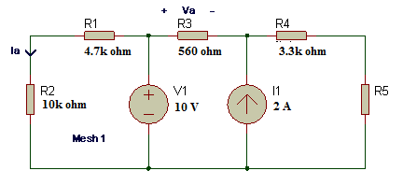

**Figure 1**

1. Find **Va** and **Ia**.

Answer: (Paste your simulated circuit)

(4 marks)

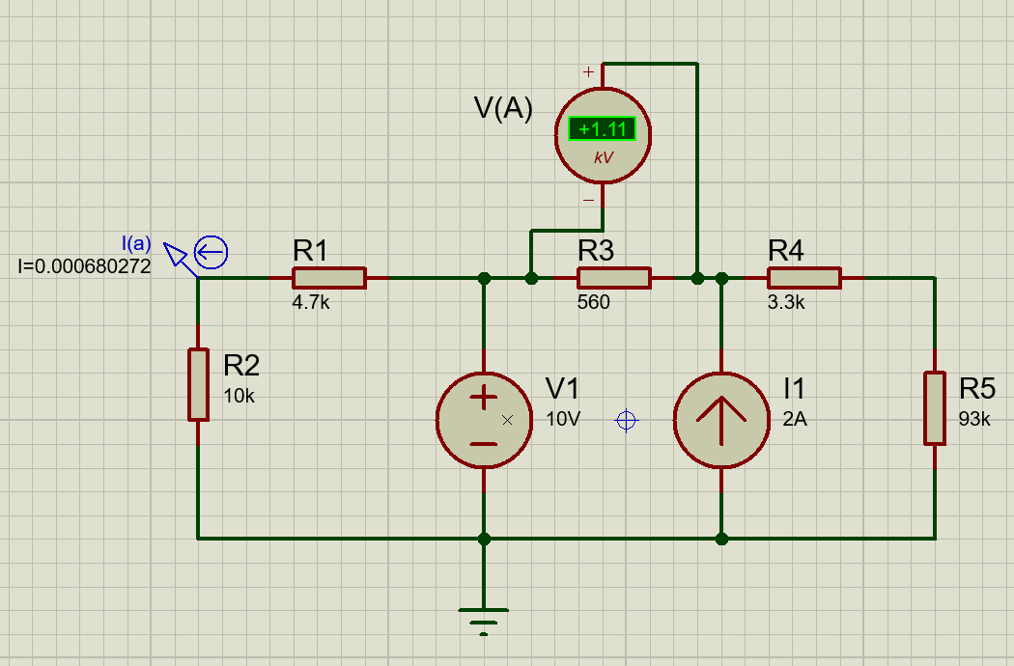

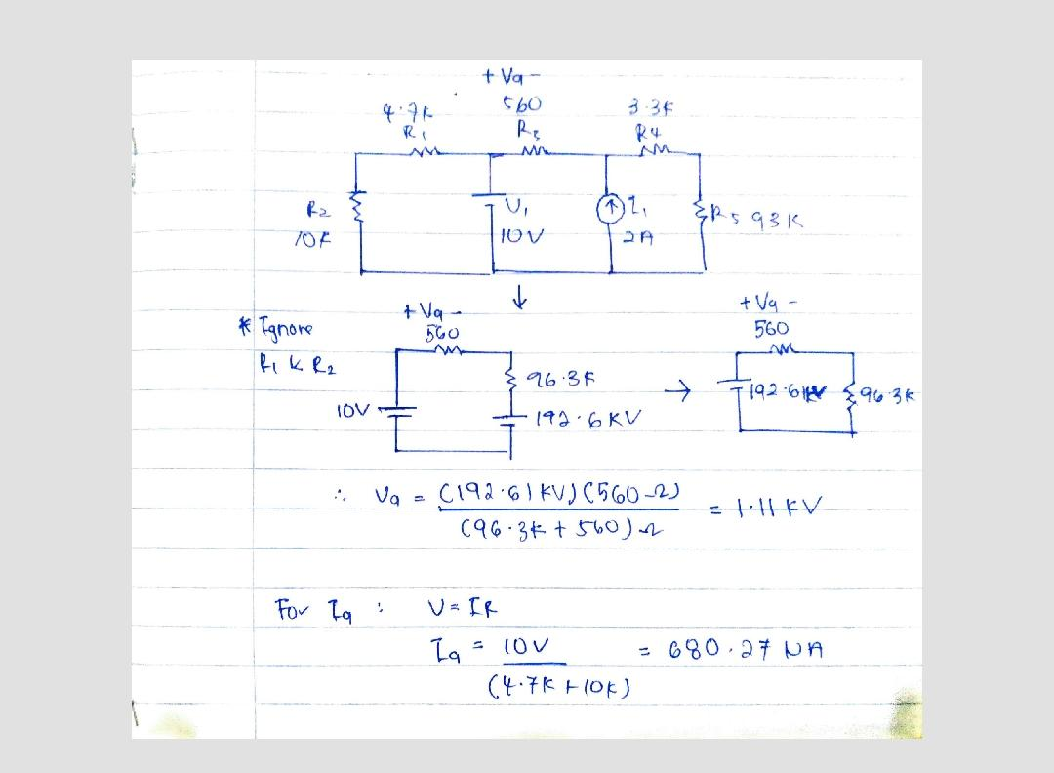

Hence = 1.11kV, = 680.27

1. Determine the power dissipated in the resistor R4.

Answer: (Paste your simulated circuit)

(6 marks)

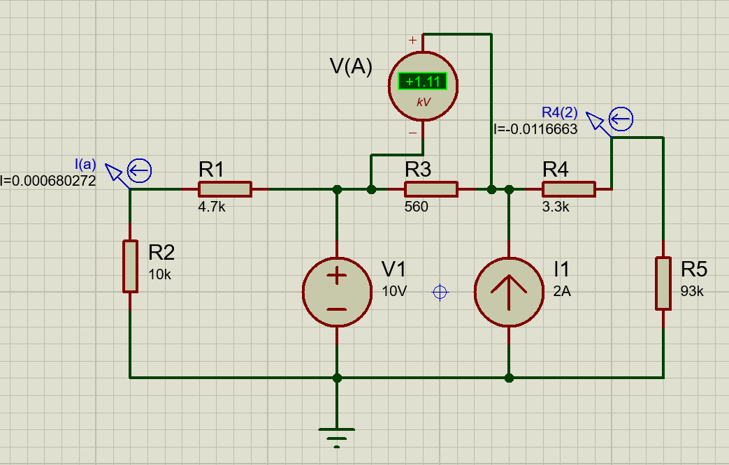

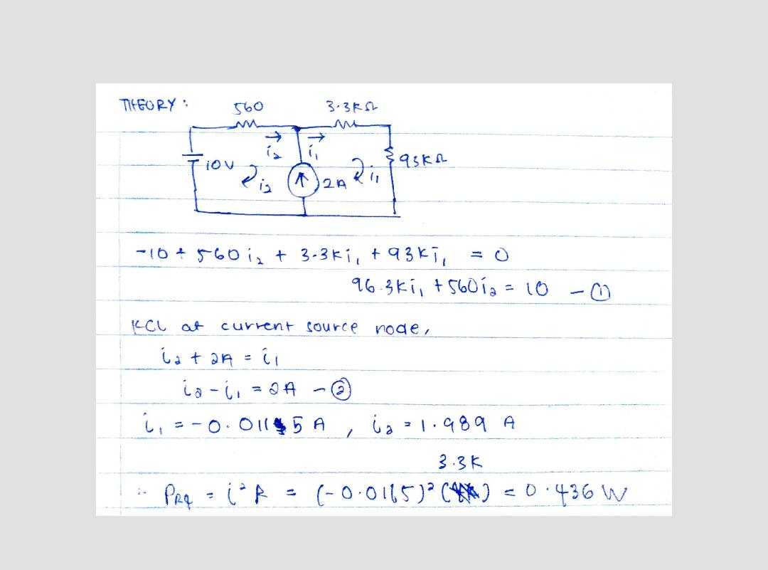

Hence, Power Dissipated by R4,

==(3.3k) =0.449W

1. Obtain its Thevenin Equivalent circuit ‘seen’ by R5 (assume R5 is the Load Resistor).

Answer: (Paste the circuit to find RTH, VTH and the Thevenin circuit).

(10 marks)

* We make an observation that R1 and R2 will have no influence on the behavior of the circuit with respect to terminal a, b. This is because they are in parallel with an ideal voltage source.
* Given that R5 is Load Resistor, hence, the circuit can be simplified:

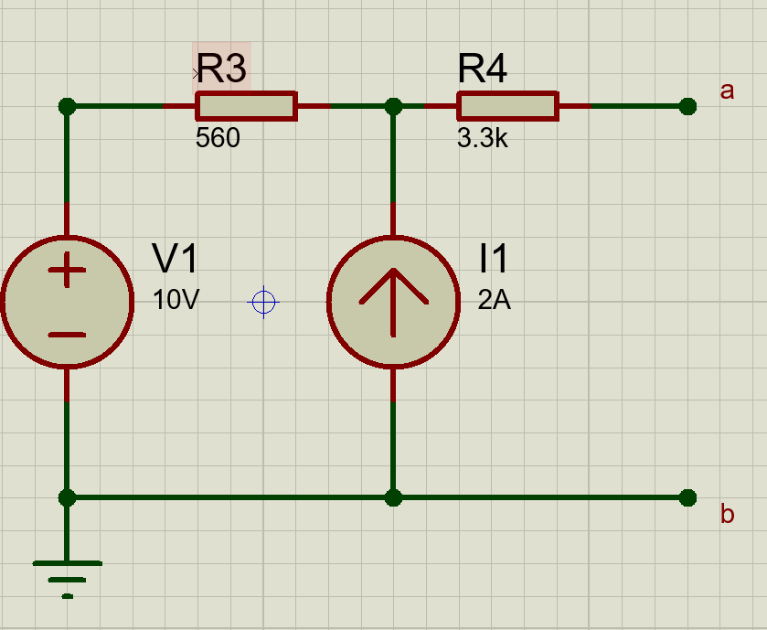

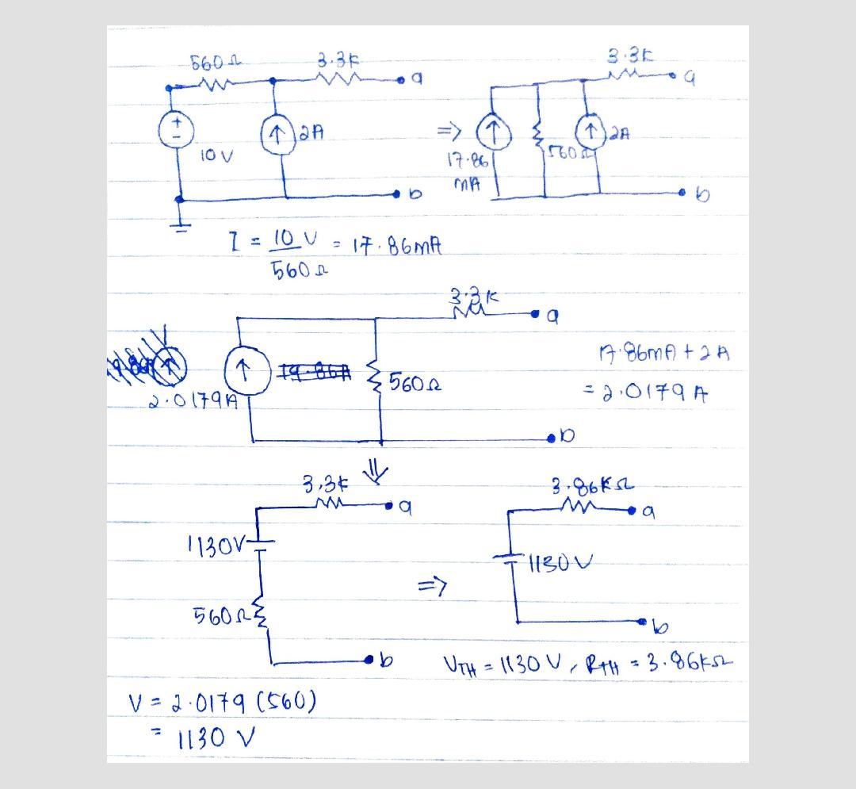

Hence, RTH = 3.86k , VTH = 1130V

And Thevenin Circuit:

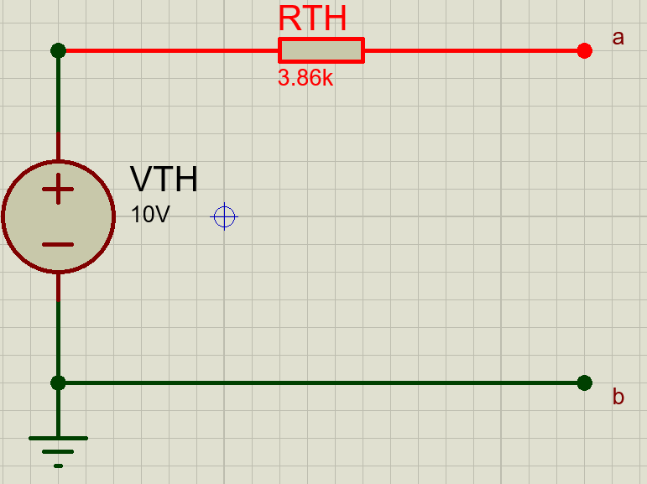

1. Construct the circuit in Figure 2. Set Vin to 5000 Hz square wave of *m* Volts peak-to-peak amplitude, R= 1kΩ and C=0.05µF (*m* is the last digit of your student number, if the last digit is 0, take the 2nd last digit and so on).

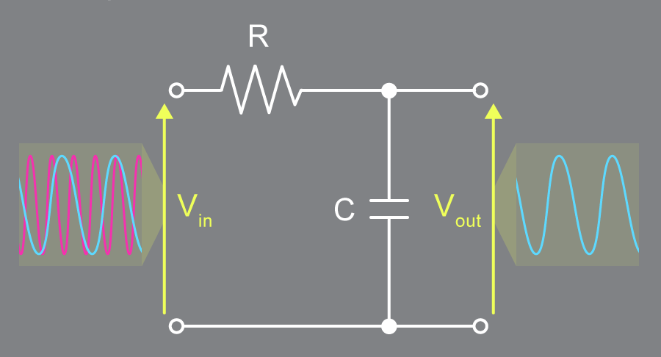

**Figure 2**

1. Simulate, screenshot and paste the Vin and Vout signals.

Answer:

(2 marks)

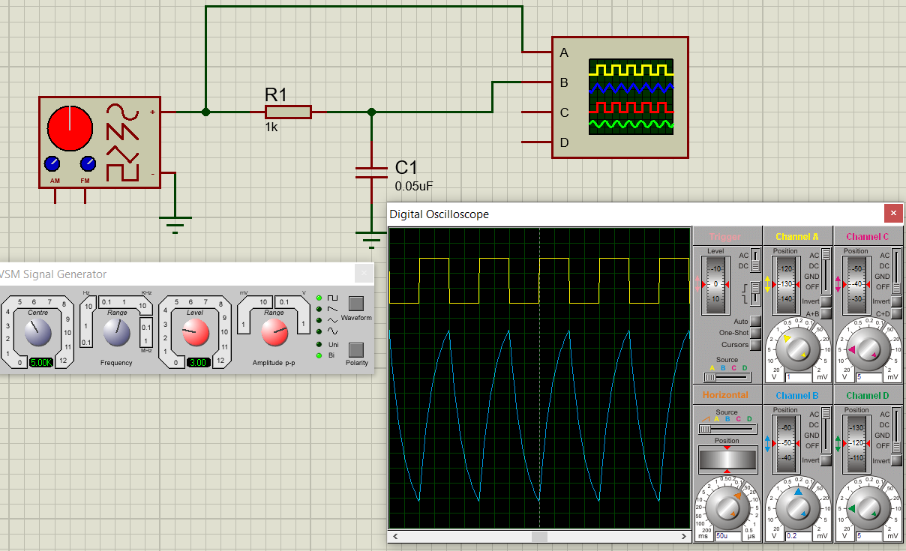

1. Measure the peak to peak of the Vout signal and phase shift.

Answer:

(6 marks)

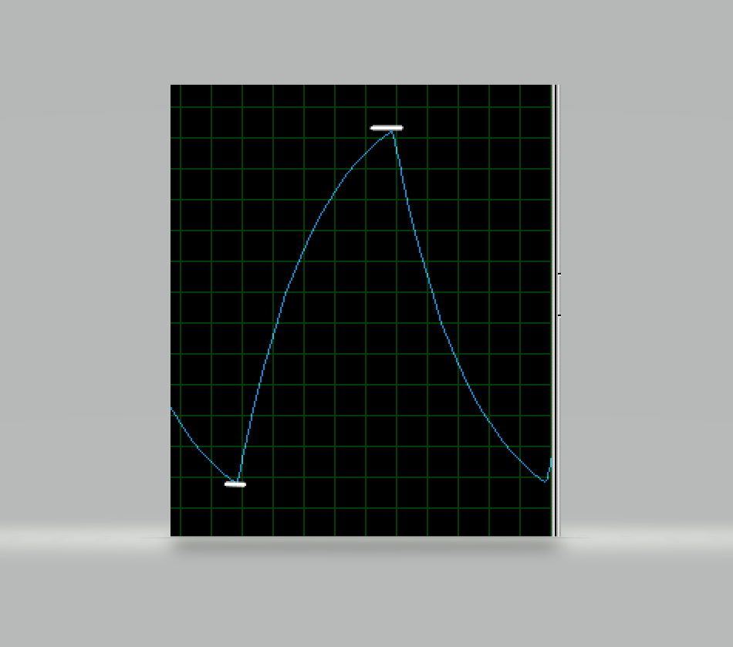

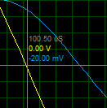 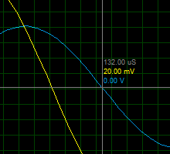

1. Connect and simulate the circuit in Figure 3. Vin is 1000 Hz, 1Vpp, VDD is 10 V and VSS is -10V. Set R3 to the last two digits of your student number in KILO ohm as in Question 1.

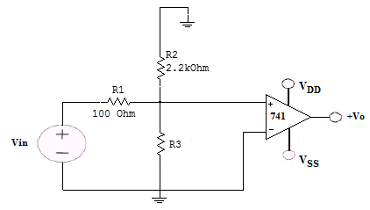

**Figure 3**

1. Screenshot and paste the Vin and Vo signals.

Answer:

(4 marks)

1. By maintaining the R3 value, modify the circuit to get gain of 2. Screenshot and paste your circuit, Vin and Vo signals.

Answer:

(6 marks)

1. For the modified circuit in b. What is the maximum amplitude of Vin before the Vo starts to distort? Screenshot and paste your simulated circuit.

Answer:

(2 marks)